Real-time Rendering for Cricket Shot Detection using Deep Learning

By

Vanagarouthu Sree Chaitran- 20BCT0205
C. Sujith Reddy- 20BCT0256 Ashok Reddy Kurapati - 20BCT0266

Executive Summary

The study presents a model based on CNN that is skilled in automatically classifying umpire gestures and cricket batting shots. The model shows great precision, correctly identifying signals from umpires such as No Action, Wide, Six, No Ball, Impact Player, Leg Bye and Out. At the same time it classifies batting actions like Pre Stance Stance Pull Shot Straight Drive. Evaluation with new datasets produced hopeful outcomes where the model reached 84.34% accuracy for classification of batting shots and 81.7% for recognizing umpire gestures.
This development has many possible applications in cricket analysis, broadcasting, and coaching. The automatic identification of umpire gestures and batting shots is helpful for understanding things quickly, especially during matches when decisions need to be made fast. It can also improve the quality of match analysis, commentary, and evaluation of player performance.
The creation of specific datasets for identifying umpire gestures and classifying shots is a big step forward. It allows models to be assessed and compared in a similar way, assisting in the continuous advancement of automatic cricket analysis.
Mainly, this study gives a lot to automated cricket analysis. The model shows high accuracies, which confirm its effectiveness and show it can be used practically as well. By setting up a base for more research and improvement, this work pledges better comprehension and assessment of cricket by fans, players, coaches and analysts too.

TABLE OF CONTENTS

CONTENTS | PAGE  NO.
Acknowledgement | i
Executive Summary | ii
Table Of Contents | iii
List Of Figures | v
List Of Abbreviations | vi
1 INTRODUCTION | 1
1.1 Objectives | 1
1.2 Motivation | 1
1.3 Background | 2
2 PROJECT DESCRIPTION AND GOALS | 3
2.1 Survey on existing system | 3
2.2 Research Gap | 5
2.3 Problem Statement | 6
3 TECHNICAL SPECIFICATIONS | 7
- Requirements  - Functional  - Non-Functional | 7  7  8
- Feasibility Study  - Technical Feasibility  - Economic Feasibility  - Social Feasibility | 9  9  9  10
- System Specifications  - Hardware Specifications  - Software Specifications | 10  10  11
4 DESIGN APPROACH AND DETAILS | 12
4.1 System Architecture | 12
- Design  - Data Flow Diagram  - Use Case Diagram | 14  14  14

- Class Diagram  - Sequence Diagram | 15  16
4.3 Constraints, Alternatives and Tradeoffs | 16
5 SCHEDULE, TASKS AND MILESTONES | 18
5.1 Gantt Chart | 18
5.2 Module Description | 18
- Testing  - Unit Testing  - Integration Testing | 19  19  20
6 PROJECT DEMONSTRATION | 21
6.1 Training the Model | 21
6.2 Testing the Model | 23
7 RESULTS AND DISCUSSIONS | 26
8 REFERENCES | 28
9 APPENDIX A – SAMPLE CODE | 29

List of Figures

Figure no | Title | Page no
4.2.1 | Data Flow Diagram | 14
4.2.2 | Use Case Diagram | 14
4.2.3 | Class Diagram | 15
4.2.4 | Sequence Diagram | 16
6.1.1 | Training the Model for Cricket Shot Detection | 21
6.1.2 | Training the Model for Umpire Pose Detection | 22
6.1.3 | Training the Model for Umpire Pose Detection | 22
6.2.1 | Testing the Model by playing Straight Drive | 23
6.2.2 | Testing the Model by playing Straight Drive | 23
6.2.3 | Testing the Model by playing Pull Shot | 24
6.2.4 | Testing the Model by Pre Stance Position | 24
6.2.5 | Testing the Model using Umpire’s Decision | 25
7.1 | Accuracy vs Epoch for Cricket Shot Detection | 27
7.2 | Accuracy vs Epoch for Umpire Pose Detection | 27

List of Abbreviations

LSTM LONG SHORT-TERM MEMORY
CNN CONVOLUTIONAL NEURAL NETWORK
DNN DEEP NEURAL NETWORKS
FLIC FRAMES LABELLED IN CINEMA
LSP LEEDS SPORTS POSE
COCO COMMON OBJECT IN CONTEXT
MPII MULTI PERSON POSE ESTIMATION
3DPW 3D POSES IN WILD
OPEN CV OPEN-SOURCE COMPUTER VISION LIBRARY

INTRODUCTION

Objective:

The primary objective is to create a custom dataset tailored for cricket shot detection and employ the MediaPipe framework for pose estimation and keypoint extraction. The extracted key points will serve as input for a Long Short-Term Memory (LSTM)-based model, enabling accurate recognition of shots played by batsmen, such as Pre Stance, Stance, Pull Shot, and Straight Drive. By integrating MediaPipe and LSTM, the objective is to improve the accuracy of gesture and shot recognition by incorporating fine-grained pose information.
The second objective is to design and implement a pose recognition system that can identify and classify specific gestures displayed by umpires.

Motivation:
We present an innovative approach that utilizes a combination of Convolutional Neural Network (CNN), Long Short-Term Memory (LSTM), and Mediapipe frameworks to address the challenges of classifying individuals on the cricket field as umpires or non-umpires, along with gesture and shot recognition. The primary objective is to enhance decision-making processes and provide real-time analysis, thus improving the overall cricketing experience.

The proposed system combines the strengths of CNN for feature extraction, LSTM for temporal modelling in cricket shot detection, and Mediapipe for pose estimation and tracking. This integration of technologies provides a comprehensive solution for automated decision-making in cricket matches, potentially elevating the accuracy, fairness, and overall standard of the game.

The scope of the project encompasses the development of an advanced system for gesture and shot recognition in cricket, leveraging state-of-the-art deep learning techniques and frameworks to enhance real-time analysis and decision support in cricket matches.

Background:
Cricket, being widely renowned as a global sport, demands precise decision-making and on-the-spot analysis throughout its matches. Conventional approaches to umpiring and identifying shots in cricket predominantly hinge on human discretion, which is subjective and susceptible to mistakes. The emergence of computer vision and machine learning methodologies has ushered in fresh avenues for automated assessment and decision-making within the cricket domain.

Apart from automated decision-making, another crucial facet of cricket analysis involves video summarization, which aims to extract key moments and highlights from cricket matches. Automated video summarization can provide concise and informative summaries, enabling viewers to quickly grasp the key events and noteworthy performances within a match. This further enhances the cricketing experience by saving time and offering an engaging presentation of the game.

PROJECT DESCRIPTION AND GOALS

Survey on Existing System:

Title of the Paper | Methodology | Drawbacks | Datasets Used
DeepPose: Human Pose Estimation via Deep Neural Networks (2014) | The authors mention the use of cascades of DNN regressors for localization, although in the context of facial points | The limitations of using local detectors and modeling only a small subset of interactions between body parts are  recognized | The paper uses two datasets for evaluation: Frames Labeled In Cinema (FLIC) and Leeds Sports Dataset (LSP)
DeepPoseKit, a software toolkit for fast and robust animal pose estimation using deep learning (2019) | Stacked DenseNet and a fast GPU-based peak-detection algorithm for estimating keypoint locations with subpixel  precision. | Requires significant training data and computational resources. | Two Datasets used :  - Groups of desert locusts  - Herds of Gre'vy's zebras
Deep Learning Based 2D Human Pose Estimation (2019) | PAFs and associative embedding, which are learned simultaneously with heatmaps, for grouping joints to  human instances. | The paper does not discuss in detail the challenges and solutions related to the detection of rare poses with an unbalanced  dataset. | The datasets mentioned in the paper include LSP, FLIC, MPII, MSCOCO, and  AI Challenger.
Human Pose Estimation using Deep Learning (2023) | DeepPose is proposed as a method to estimate human pose as a regression problem using a convolutional neural network (CNN) for extracting discriminatory features | The focus on deep learning methods for HPE, potentially overlooking other  approaches or techniques that may also be effective. | Leeds Sports Pose (LSP)
Human Movement Detection and Identification Using  Pyroelectric Infrared Sensors (2014) | Two pairs of PIR sensors orthogonally aligned, one ceiling and two on walls | The trade-off between recognition accuracy and computational  load was not thoroughly explored | Collected a dataset from eight subjects walking in three different conditions
A System for Detection and Tracking of Human Movements Using RSSI Signals (2018) | The proposed method detects and tracks humans based on changes in the measured RSSI values, which indicate the presence and  movements of humans | RSSI signals may be affected by  interference and signal attenuation. | N/A
A Mutually Enhanced Modeling Method for  Efficient and Effective | A mutually enhanced modeling method | The limitations of the MEMe method in  terms of | N/A

Human Pose Estimation (2022) | (MEMe) for human pose estimation | generalizability to  other datasets or pose estimation tasks
Yoga pose perfection using Deep Learning: An Algorithm to Estimate the Error in Yogic Poses (2024) | The method involves defining a yoga pose in a numerical sense by calculating angles between certain body parts using pose  estimation. | Did not discussed in the paper | Kaggle dataset
Low-resolution human pose estimation (2022) | CAL selectively weighs the learning of heatmap and offset based on ground-truth and confident predictions, capturing the statistical importance of model output in mini-batch  learning | Need for resolution recovery due to downsampling operations, which can introduce quantization errors and negatively affect model performance. | COCO (Common Objects in Context) dataset
A Survey Of Computer Vision-Based Human Motion Capture (2001) | Flow information and down-sampling are used to represent image information in a compact manner, which is then processed by a  classifier for recognition | The paper primarily serves as a survey of existing methods rather than a critical evaluation of their limitations. | N/A
Using Imitation Learning for Human Motion Control in a Virtual Simulation by Christoffer Akrin (2022) | The paper evaluates the proposed approach using a variety of virtual characters and tasks, including walking, running, and  jumping | The proposed approach is only evaluated using a limited number of virtual characters and tasks | 3DPW Dataset
Machine Learning- Based Exercise Posture Recognition System Using MediaPipe Pose Estimation Framework (2023) | The paper uses the MediaPipe pose estimation framework to extract body skeleton sequences from video data recorded by a fitness  specialist through a simple web camera. | The evaluation of the system's performance is based on a test data set for only three types of exercises, which may not fully represent the variability and  complexity of different exercise postures. | MPII dataset
Mimicking Human Player Strategies in Fighting Games Using Game Artificial Intelligence Techniques (2014) | The paper evaluates the proposed approach using a simple fighting game called Street Fighter Zero. The  replay data is collected from a human player | The dataset used in the paper is relatively small, consisting of only 100 replay matches. This is a  limitation of the study, as a larger dataset | Replay data of 100 replay matches.

 | who has a win rate of over 70%. | would likely lead to better results
Human Gait Analysis Using Machine Learning: A Review (2021) | The paper provides a comprehensive overview of the use of machine learning for  gait analysis | Only Limited to analyze the walking patterns for gait disorder | GaitRite Dataset
LiveCap: Real-time Human Performance Capture from Monocular Video (2019) | Two-stage analysis- by-synthesis optimization approach for real-time human performance capture from monocular video | The proposed approach is only able to capture  performances of people wearing certain types of clothing, such as loose-fitting  clothing | LiveCap Dataset

  - Research Gap:

While previous studies have explored automating certain aspects of cricket analysis, our proposed system recognized a lack of comprehensive systems that integrate different components. We aimed to bridge this gap by proposing an approach that combines techniques for recognizing umpire gestures, and detecting cricket shots played by batsmen. We acknowledged the absence of publicly available datasets specifically designed for cricket shot detection.

To address this limitation, our proposed system created a custom dataset by manually recording various cricket shots, enabling the development and evaluation of their shot classification model. Despite efforts in event detection and classification in cricket videos, we identified a gap in the specific task of accurately recognizing and categorizing umpire gestures, such as No Action, Wide, Six, No Ball, Impact Player, Leg bye and Out.
Our proposed system aimed to fill this gap, potentially contributing to better decision-making and analysis during matches. The paper proposed a novel approach that integrated multiple deep learning techniques, including Convolutional Neural Networks (CNNs), Long Short-Term Memory (LSTM) networks, and the MediaPipe framework for pose estimation. By combining these techniques, we aimed to address the research gap in providing a comprehensive solution for automated cricket analysis, encompassing umpire classification, gesture recognition, and shot detection.

While previous studies focused on post-match analysis or highlight generation, the proposed system targeted real-time analysis and decision support during live cricket matches. By providing real-time insights into umpire gestures and batsman shots, the system addressed the need for automated analysis and decision-making support during ongoing matches.
Our proposed system recognized the potential of automated video summarization techniques in enhancing the viewing experience of cricket matches. By incorporating methods for extracting key moments and highlights, the proposed system aimed to address the research gap in generating concise and engaging summaries of cricket matches. In summary, we identified research gaps in the lack of comprehensive systems, robust datasets, umpire gesture recognition, integration of multiple techniques, real-time analysis, and automated video summarization for cricket matches, and proposed an approach to address these gaps.

Problem Statement:
During cricket matches, accurate decisions and real-time analysis are crucial, but relying solely on human judgment for umpire decision- making and shot recognition can be subjective and error-prone. There is a need for an automated system that can reliably distinguish umpires, accurately identify, and categorize umpire gestures (such as No Action, Wide, Six, No Ball, Impact Player, Leg Bye and Out), and precisely detect and classify various cricket shots played by batsmen. Furthermore, the system should incorporate techniques for automated video summarization, allowing for the extraction of key moments and highlights from the matches, thereby improving the overall viewing experience for spectators. In essence, the problem statement highlights the need for an automated system that can enhance decision-making processes, provide real-time analysis, and generate concise summaries during cricket matches by leveraging advanced techniques like deep learning, computer vision, and video processing. The proposed system aims to address the limitations of human judgment and manual analysis, while also enhancing the overall cricketing experience for viewers, players, and officials.

TECHNICAL SPECIFICATIONS

Requirements:
    - Functional:
      - Data Collection and Preparation:

Requirement: Gather a diverse dataset of cricket match videos capturing various gestures and shots.
Description: Collect annotated video data including different types of cricket gestures (e.g., No Action, Wide, Six, No ball, Out, Leg bye, Impact Player) and shots (e.g., Pre Stance, Stance, Pull Shot, Straight Drive).

      - Dataset Annotation:

Requirement: Annotate the collected dataset with ground truth labels for gestures and shots.
Description: Label each video frame or sequence with the corresponding cricket gesture or shot type to facilitate supervised learning.

      - Model Development:

Requirement: Implement deep learning models using CNN and LSTM architectures.
Description: Develop and train CNN for image-based gesture recognition and LSTM networks for sequence modeling of shot actions.

      - Integration with MediaPipe Framework:

Requirement: Integrate the developed models with the MediaPipe framework.
Description: Utilize MediaPipe for real-time processing and inference of cricket gestures and shots, enabling efficient analysis during live matches.

      - Real-time Analysis:

Requirement: Achieve real-time performance for gesture and shot recognition.
Description: Ensure that the system can process incoming video streams from cricket matches in real-time, providing instantaneous analysis and feedback.

      - Testing and Validation:

Requirement: Perform rigorous testing and validation of the entire system.
Description: Conduct testing under various conditions and scenarios to validate the robustness and generalization capability of the gesture detection and shot recognition system.

Non- Functional:

- Performance:

Requirement: The system must provide real-time performance, with low latency and high throughput.
Description: Ensure that the gesture and shot recognition algorithms can process video streams efficiently during live cricket matches without significant delays.

- Accuracy:

Requirement: Achieve high accuracy in gesture and shot classification.
Description: The system should accurately recognize and classify cricket gestures and shots with a high degree of precision to support reliable decision-making during matches.

- Scalability:

Requirement: The system should be scalable to handle varying workloads and accommodate multiple concurrent users.

Description: Design the architecture such that it can scale up to process data from different cricket matches simultaneously and support increased computational demands.

- Robustness:

Requirement: Ensure robustness against variations in lighting, camera angles, and player movements.
Description: The system should be resilient to noise and environmental factors commonly encountered in live cricket match settings to maintain consistent performance.

- Security:

Requirement: Implement measures to protect the system from unauthorized access and data breaches.
Description: Incorporate security features to safeguard sensitive data, such as match footage and analysis results, from potential threats or unauthorized usage.

Feasibility Study:

    - Technical Feasibility:

The research paper demonstrates the technical viability of the proposed system by successfully implementing deep learning techniques like CNNs, LSTMs, and the MediaPipe framework for cricket shot detection and umpire pose recognition. The reported accuracy levels indicate that the technical approach is feasible. However, the authors acknowledge limitations and suggest future improvements, such as expanding datasets, exploring advanced architectures, and incorporating additional features.

Economic Feasibility:

The system could potentially generate revenue streams and economic benefits for stakeholders in the cricket industry, such

as broadcasters, analytics firms, and coaching institutions. By automating match analysis, providing real-time insights, and supporting decision-making, the system could create value.

Social Feasibility:

The proposed system shows promising social feasibility as it aims to enhance the overall cricketing experience for viewers, commentators, coaches, and players. By providing automated analysis and real-time insights into umpire gestures and batsman shots, the system can contribute to more accurate and fair decision-making processes, increasing transparency and credibility of the sport. Additionally, it can aid in coaching and player development by providing valuable insights for feedback and training methodologies. The potential for automated video summarization could further enhance the viewing experience and social appeal of cricket.

System Specifications:

    - Hardware Specifications:

- CPU: Multi-core processors (e.g., Intel Core i5 or equivalent) to handle parallel computations efficiently. Preferably, CPUs with high clock speeds and good cache sizes for faster data processing.

- GPU (Graphics Processing Unit): Dedicated GPUs (e.g., NVIDIA GeForce RTX or Intel Iris xe series) with CUDA support for accelerating deep learning tasks.
More powerful GPUs such as NVIDIA Tesla or Quadro RTX for large-scale model training and inference.

- RAM: Adequate RAM capacity (e.g., 16 GB to 32 GB or more) to accommodate data processing and model training requirements. Higher RAM capacity is beneficial for handling large datasets and complex model architectures.

- Storage: Solid State Drive (SSD) or NVMe SSD for fast data access and model loading. Sufficient storage capacity to store datasets, model checkpoints, and related resources.

Software Specifications:

- Deep Learning Frameworks:
TensorFlow: A popular open-source deep learning library developed by Google. TensorFlow provides tools and resources for building and training neural network models.
PyTorch: Another widely used deep learning framework known for its flexibility and ease of use, developed by Facebook's AI Research lab (FAIR).

- MediaPipe:
Google's MediaPipe framework for building real-time multi-modal (e.g., video, audio) applications. MediaPipe includes pre-built solutions for tasks like hand tracking, pose estimation, and object detection, which can be utilized for gesture detection in cricket.

- OpenCV (Open Source Computer Vision Library):
OpenCV provides a comprehensive set of tools and algorithms for image and video processing. It can be used for tasks such as video capture, frame manipulation, and feature extraction.

- Python Programming Language:
Python is commonly used for implementing machine learning and deep learning algorithms due to its simplicity, readability, and extensive libraries for data manipulation and visualization.

IDE (Integrated Development Environment):
Visual Studio Code.

DESIGN APPROACH AND DETAILS

System Architecture:

Mediapipe Pose Detection:

Pose Detection: x, y, z and Visibility = 4, Unpacked across 33 points, 33*4 = 132,

Face Detection (FaceMesh): x, y, z = 3, Unpacked across 468 points, 468*3= 1404,

Left Hand Detection: x, y, z = 3, Unpacked across 21 points, 21*3= 63,

Right Hand Detection: x, y, z = 3, Unpacked across 21 points, 21*3= 63,

Total: 132 + 1404 + 63 + 63 = 1662 points.

Given a Frame we calculate the co-ordinates of 1662 points.

For training we split the data into 30 frames and send it to the model for prediction of action (Pre-Stance, Stance, Straight Drive, Pull Shot) based on these 1662 points across 30 frames in a video.

So, input to the model is 30*30*1662 per action (i.e 30 videos per action with 30 frames per video and 1662 points per frame.)

This input is provided to the LSTM model,

Input to the model
(30 Frames * 1662 body points)

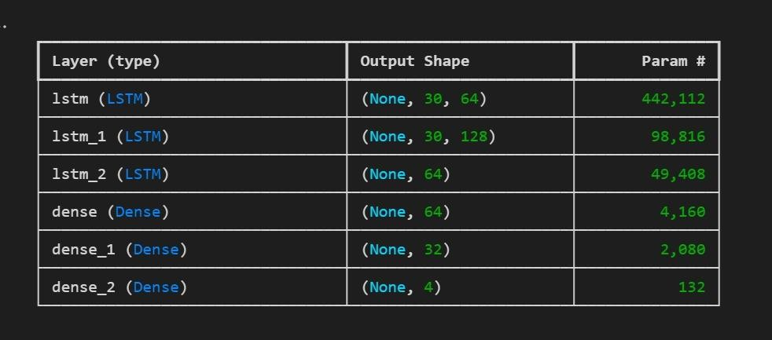

Umpire Pose Detection:

The dataset comprised cricket video images containing umpire gestures from seven classes: "No Action," "No Ball," "Out," "Six", "Impact player", "Legbye", and "Wide." It was split into training (over 300 images) and test sets (80 images).

Images were preprocessed using TensorFlow's ImageDataGenerator, rescaling pixel values to [0, 1] range for better model convergence. No other augmentation was applied.

The CNN model architecture consisted of Conv2D layers with increasing filter sizes (32, 64, 128, 256) and 3x3 kernels, followed by ReLU activations and MaxPooling2D layers for downsampling.

After flattening, two Dense layers (512 units each) with ReLU activations preceded the final Dense layer with softmax activation for class probability output. The model used Adam optimizer, categorical cross- entropy loss, and trained for 30 epochs with a batch size of 16. Validation set performance monitoring helped detect overfitting/underfitting during training.

Design:

    - Data Flow Diagram:

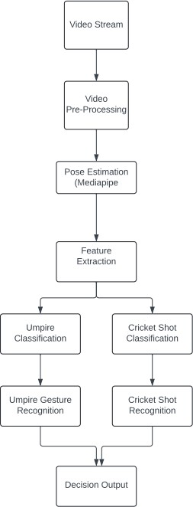
Fig 4.2.1 – Data Flow Diagram

Use Case Diagram:

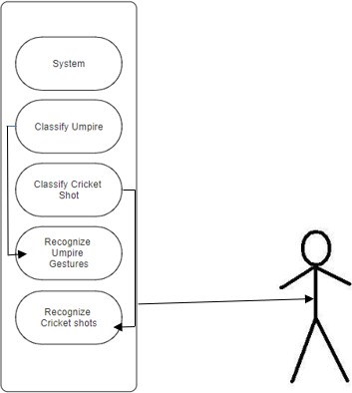
Fig 4.2.2 – Use Case Diagram
User

Class Diagram:

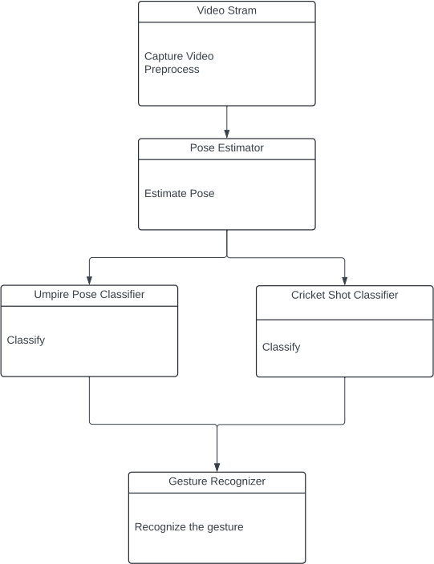
Fig 4.2.3 – Class Diagram

Sequence Diagram:
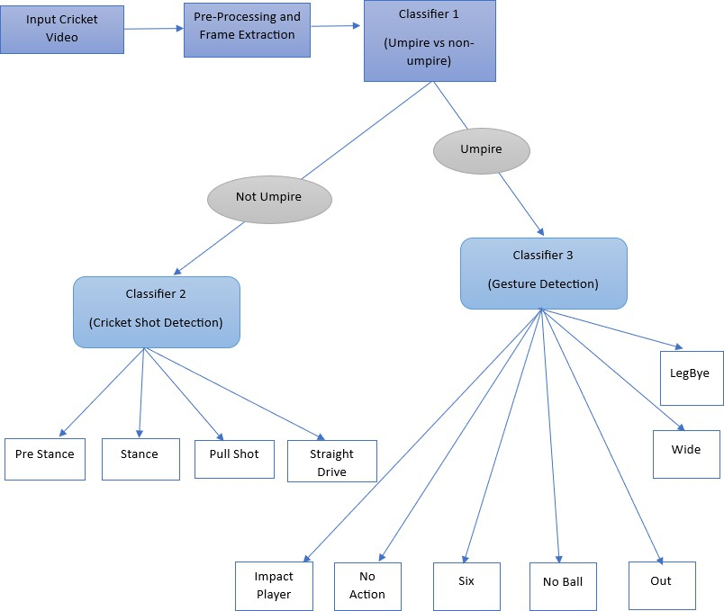
Fig 4.2.4 – Sequence Diagram

Constraints, Alternatives and Trade-off’s: Constraints:
- Limited dataset size and diversity could restrict the model's ability to generalize across various scenarios.
- Powerful computational resources like high-end CPUs, GPUs, and ample memory are required, which may pose constraints due to resource limitations.
- Varying lighting conditions on the field, such as shadows, glare, or low light, could affect the input video quality and pose challenges for computer vision algorithms.
- Occlusion of players/umpires and varying viewpoints might impact the accuracy of pose estimation, gesture recognition, and shot classification.

Alternatives and Trade-offs:

- Expanding datasets through data augmentation techniques or generating synthetic data could address dataset limitations but may require significant effort and resources.
- Leveraging cloud computing or distributed processing frameworks could overcome computational resource constraints but may increase costs and introduce potential latency issues.
- Trading off accuracy for real-time performance or vice versa might be necessary, involving a choice between lightweight models or prioritizing accuracy over speed for certain applications.
- Multi-view or ensemble models combining predictions from different camera angles could address occlusion and viewpoint variations but might increase computational complexity and require additional training data.
- Adaptive algorithms or preprocessing techniques could be explored to handle varying lighting conditions, but these may introduce additional computational overhead while improving overall robustness.

SCHEDULE, TASKS AND MILESTONES

Gantt Chart:
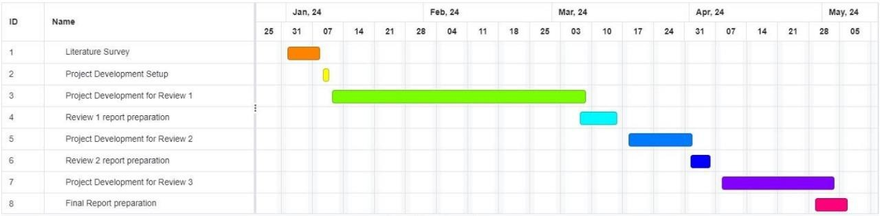

  - Module Description:

- cv2: This is the OpenCV module for computer vision tasks in Python. It is used for capturing video feed, reading, and writing images, and drawing landmarks on the frames.
- mediapipe (mp_holistic, mp_pose): These are modules from the MediaPipe library, which is a cross-platform library for building multimodal applied machine learning pipelines. In this case, the mp_holistic module is used for holistic pose estimation (detecting pose, face, and hand landmarks), while mp_pose is used for pose estimation specifically.
- mp_drawing: This is another module from the MediaPipe library, which provides utilities for drawing landmarks and connections on the frames.
- mp_drawing_styles: This module from MediaPipe provides predefined drawing styles for landmarks.
- numpy (np): NumPy is a fundamental library for scientific computing in Python. It is used for numerical operations and array manipulations.
- os: This is the built-in Python module for interacting with the operating system, which is likely used for handling file paths in the code.
- keras or tensorflow: These deep learning libraries might be used for loading and running the pre-trained model for shot classification.

- collections: This built-in module provides specialized container data types, which could be used for handling data structures efficiently.

Testing:

    - Unit Testing:

Video Preprocessing: Test cases to verify the correct resizing and normalization of input video frames.
Tests to ensure the preprocessing pipeline handles different frame sizes, aspect ratios, and color spaces correctly.

Pose Estimation: Test cases to validate the accuracy of landmark detection on sample images with known ground truth.
Tests to check the handling of occluded or partially visible poses. Tests to verify the correctness of coordinate transformations and output formats.

Feature Extraction: Unit tests to ensure the correct extraction of keypoints from the pose estimation results.
Tests to validate the handling of different input formats and edge cases.

Cricket Shot Classification: Unit tests to assess the classification accuracy on a separate test set.
Tests to validate the handling of different sequence lengths or input shapes.
Tests to check the correct interpretation of output probabilities or labels.

Umpire Gesture Recognition: Test cases to evaluate the recognition accuracy on a hold-out test set.
Tests to check the handling of different input sizes and formats. Tests to verify the correct interpretation of output probabilities or labels.

Utility Functions: Unit tests for any helper functions or utility modules used in the codebase, such as drawing functions, data preprocessing functions, or file I/O operations.

Integration Testing:

Video Stream Integration: Tests to ensure the correct capture and processing of video streams from different sources (e.g., cameras, video files).
Tests to validate the seamless integration of the video stream with the pose estimation and feature extraction components.

Pose Estimation and Feature Extraction Integration: Tests to verify the correct flow of data from the pose estimation module to the feature extraction module.
Tests to ensure the accurate extraction of keypoints from the pose estimation results.

Decision Output Integration: Tests to verify the correct integration of the classification and recognition results into a unified decision output format.

User Interface Integration: Tests to verify the correct rendering and updating of the user interface with the decision outputs and video streams.
Tests to ensure the proper handling of user interactions and input events.

PROJECT DEMONSTRATION

Training the Model:

For Cricket shot identification 30 videos for each shot has been taken and trained, for umpire pose detection over 300 images have been used to train,
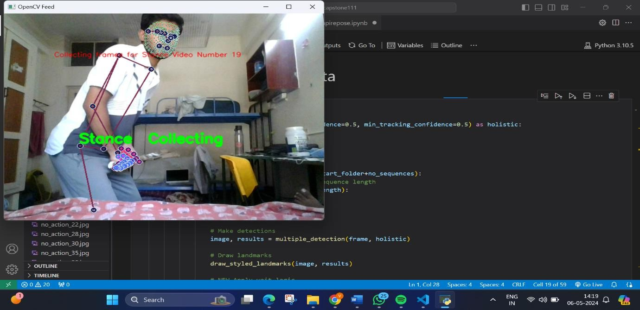
Fig 6.1.1 – Training the Model for Cricket Shot detection

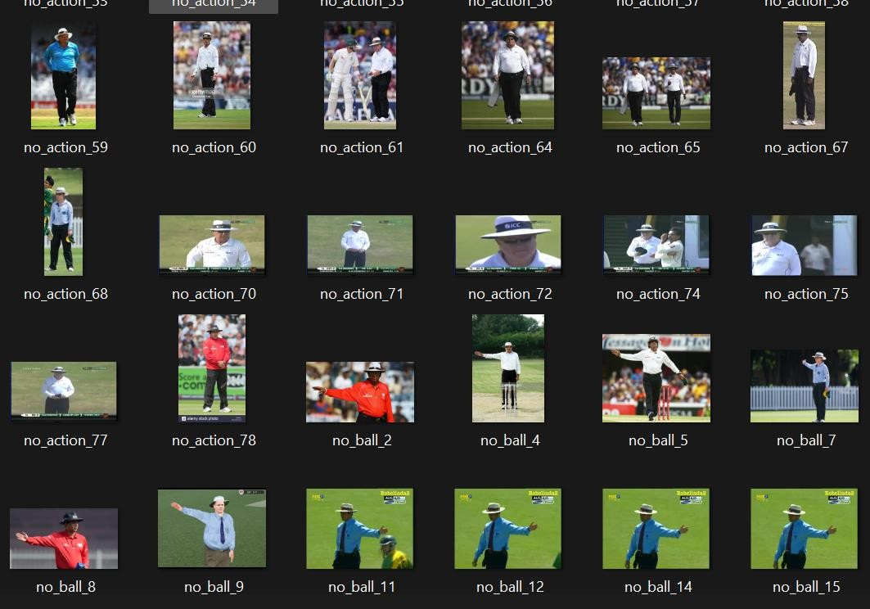
Fig 6.1.2 – Training the Model for Umpire Pose Detection
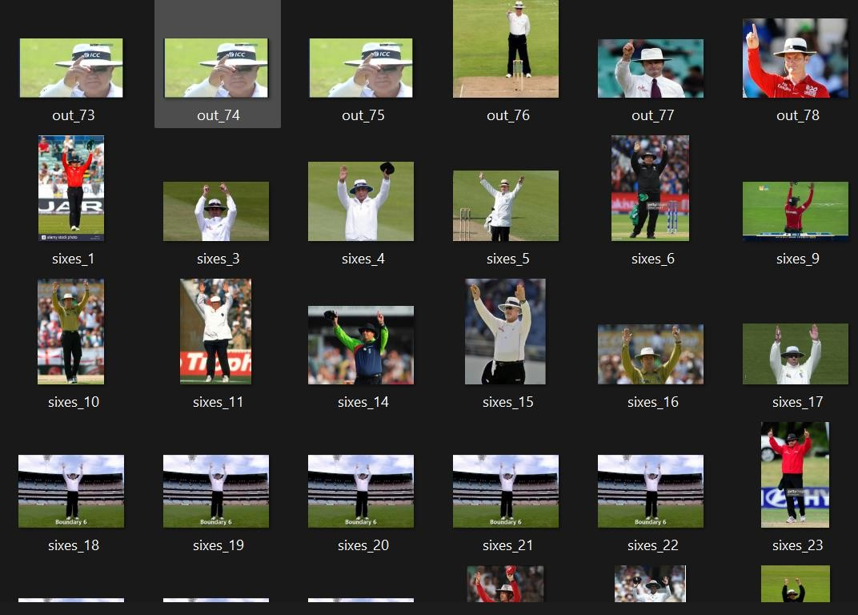
Fig 6.1.3 – Training the Model for Umpire Pose Detection

Testing the Model:

Cricket Shot Identification:

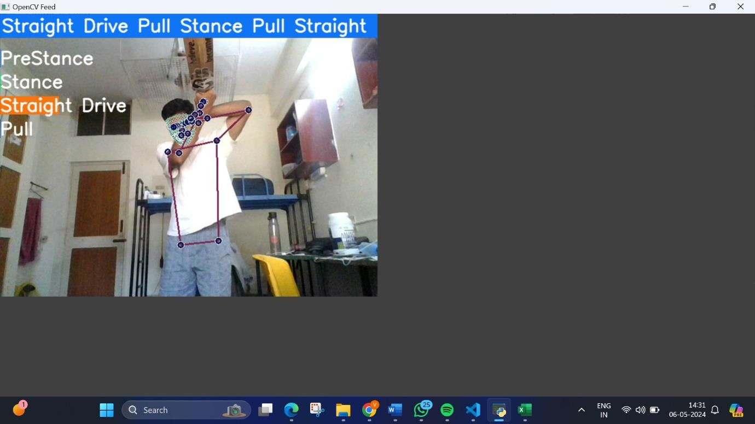
Straight Drive:
Fig 6.2.1 – Testing the Model by playing Straight Drive
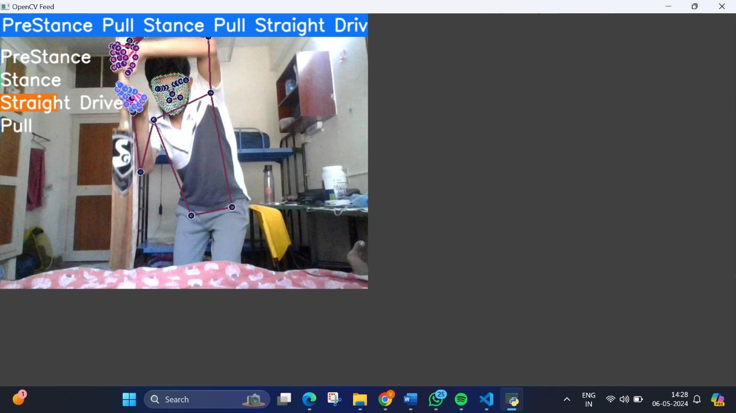
Fig 6.2.2 – Testing the Model by playing Straight Drive

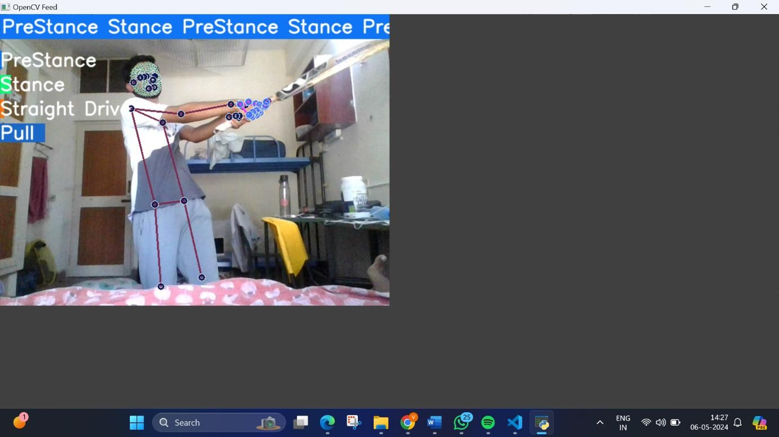
Pull:
Fig 6.2.3 – Testing the Model by playing Pull Shot

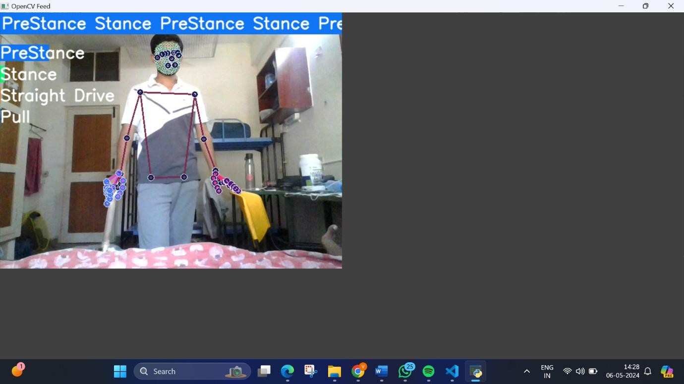
PreStance:
Fig 6.2.4 – Testing the Model by Pre stance position

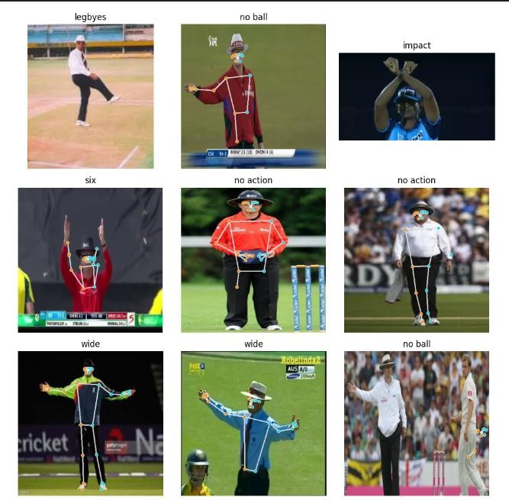
Umpire Pose Detection:
Fig 6.2.5 – Testing the Model Using Umpire’s decisions

RESULTS AND DISCUSSIONS

This research successfully developed and implemented a CNN- based model that can automatically classify umpire gestures and batting shots in cricket matches. The model demonstrated high accuracy in distinguishing umpires and recognizing specific gestures like No Action, Wide, Six, No Ball, Impact Player, Leg Bye and Out displayed by umpires. Additionally, it performed impressively in detecting and categorizing various cricket shots played by batsmen, such as Pre Stance, Stance, Pull Shot, and Straight Drive. When evaluated on the newly curated datasets, the model achieved an accuracy of 84.34% for classifying the four types of batting shots, and 81.7% for gesture recognition. These results validate the proposed approach's effectiveness in accurately categorizing umpire gestures and batsmen actions on the field.

The developed model shows great potential for practical applications in cricket analysis, broadcasting, and coaching. By automating the recognition of umpire gestures and batting shots, it can provide real- time insights and support decision-making during live matches. Identifying specific gestures and shots can enhance match analysis, commentary, and player performance evaluation.

The introduction of new datasets specifically designed for umpire gesture detection and shot classification contributes to advancing research in this field. These datasets enable researchers and practitioners to evaluate and compare different models' performance in a standardized manner, fostering advancements in automated cricket analysis.

Overall, this research paper presents a valuable contribution to automated cricket analysis by developing a CNN-based model for classifying umpire gestures and batting shots. The achieved accuracies demonstrate the model's effectiveness and potential for real-world applications. This work paves the way for further research and development, ultimately enhancing the understanding and analysis of the beloved sport of cricket.

TABLE 1: Classifier Performance Comparison

S. NO. | CLASSIFIER | ACCURACY
1. | Cricket Shot Detection | 84.34%
2. | Umpire Pose Detection | 81.7%

Cricket Shot Detection (Accuracy vs Epoch):
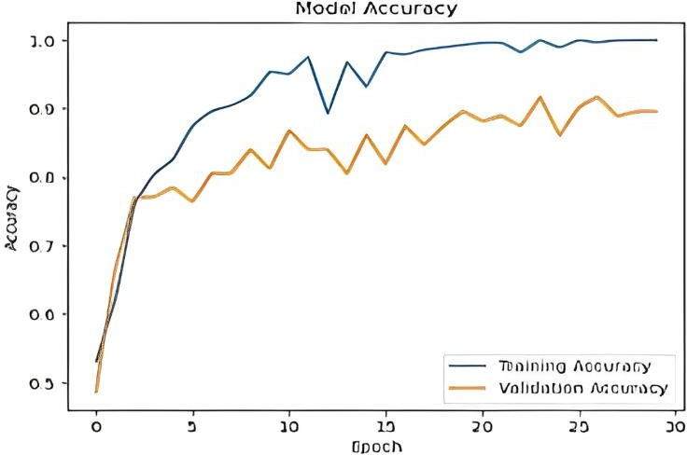
Fig 7.1 – Accuracy vs Epoch for Cricket shot detection

Umpire Pose Detection (Accuracy vs Epoch):
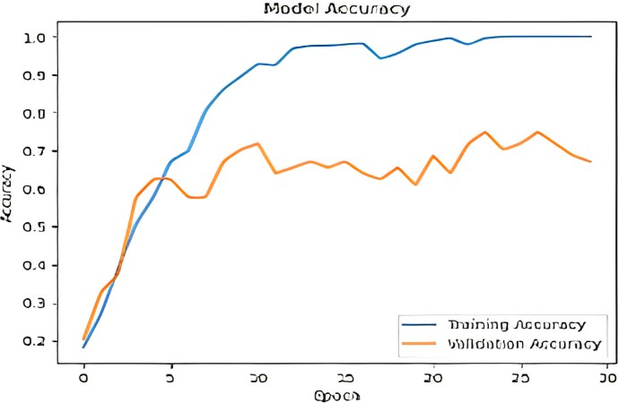
Fig 7.2 – Accuracy vs Epoch for Umpire Pose detection

REFERENCES

- Alexander Toshev, Christian Szegedy, DeepPose: Human Pose Estimation via Deep Neural Networks, 2014
- Jacob M Graving, Daniel Chae, Hemal Naik, Liang Li, Benjamin Koger, Blair R Costelloe, Iain D Couzin, DeepPoseKit, a software toolkit for fast and robust animal pose estimation using deep learning, 2019
- Qi Dang, Jianqin Yin, Bin Wang, Wenqing Zheng, Deep learning based 2D human pose estimation: A survey, 2019
- Jaeseok Yun and Sang-Shin Lee, Human Movement Detection and Identification Using Pyroelectric Infrared Sensors, 2014
- Apidet Booranawong, Nattha Jindapetch, Hiroshi Saito, A System for Detection and Tracking of Human Movements Using RSSI Signals, 2018
- Jie Li, Zhixing Wang, Bo Qi, Jianlin Zhang and Hu Yang, MEMe: A Mutually Enhanced Modeling Method for Efficient and Effective Human Pose Estimation, 2022
- Satyam Goyal, Animesh Jain, Yoga Pose Perfection using Deep Learning, 2024
- C Wang, F Zhang, X Zhu, SS Ge, Low-resolution human pose estimation, 2022
- TB Moeslund, E Granum, A survey of computer vision-based human motion capture, 2001
- C Akrin, Using Imitation Learning for Human Motion Control in a Virtual Simulation, 2022
- W Supanich, S Kulkarineetham, P Sukphokha, P Wisarnsart, Machine learning-based exercise posture recognition system using mediapipe pose estimation framework, 2023
- SS Saini, Mimicking human player strategies in fighting games using game artificial intelligence techniques, 2014
- SM Alfayeed, BS Saini, Human gait analysis using machine learning:
A review, 2021
- M Habermann, W Xu, M Zollhoefer, G Pons-Moll, C Theobalt, Livecap: Real-time human performance capture from monocular video, 2019

APPENDIX A - SAMPLE CODE

Cricket Shot Identification:

import cv2
import mediapipe as mp import numpy as np

# Initialize MediaPipe Holistic model mp_holistic = mp.solutions.holistic

# Initialize detection variables sequence = []
sentence = [] predictions = [] threshold = 0.5

# Start capturing video feed from webcam cap = cv2.VideoCapture(0)

# Main loop for real-time processing
with mp_holistic.Holistic(min_detection_confidence=0.5, min_tracking_confidence=0.5) as holistic:
while cap.isOpened(): # Read video feed
ret, frame = cap.read()

# Perform multiple detections using holistic model image, results = multiple_detection(frame, holistic) print(results)

# Draw landmarks on the image draw_styled_landmarks(image, results)

# Extract keypoints and add to the sequence keypoints = extract_keypoints(results) sequence.append(keypoints)
sequence = sequence[-30:]

# Perform prediction if sequence length is 30 if len(sequence) == 30:
res = model.predict(np.expand_dims(sequence, axis=0))[0] print(actions[np.argmax(res)]) predictions.append(np.argmax(res))

# Update sentence based on prediction
if np.unique(predictions[-10:])[0] == np.argmax(res): if res[np.argmax(res)] > threshold:
if len(sentence) > 0:
if actions[np.argmax(res)] != sentence[-1]: sentence.append(actions[np.argmax(res)])
else:
sentence.append(actions[np.argmax(res)])

# Limit sentence length to 5 if len(sentence) > 5:
sentence = sentence[-5:]

# Visualize probabilities
image = prob_viz(res, actions, image, colors)

# Display sentence on top of the video feed cv2.rectangle(image, (0, 0), (640, 40), (245, 117, 16), -1)
cv2.putText(image, ' '.join(sentence), (3, 30),
cv2.FONT_HERSHEY_SIMPLEX, 1, (255, 255, 255), 2, cv2.LINE_AA)

# Show the video feed with processed information cv2.imshow('OpenCV Feed', image)

# Break loop if 'q' is pressed
if cv2.waitKey(10) & 0xFF == ord('q'): break

# Release resources cap.release() cv2.destroyAllWindows()

Umpire Pose Detection:

import cv2 import os import random
import numpy as np import mediapipe as mp

# Initialize MediaPipe Pose model mp_pose = mp.solutions.pose mp_drawing = mp.solutions.drawing_utils
mp_drawing_styles = mp.solutions.drawing_styles

# Define file paths for images paths0 = []
for dirname, _, filenames in os.walk("D:\\capstone111\\umpire\\train"): for filename in filenames:
if filename.endswith('.jpg'): paths0.append(os.path.join(dirname, filename))
print(paths0[:3])

# Randomly select 200 image paths for processing paths = random.sample(paths0, 200)

# Define action labels and their abbreviated forms names = ['no action', 'no ball', 'out', 'six', 'wide']
names_ab = ['no_a', 'no_b', 'out_', 'sixe', 'wide'] normal_mapping = dict(zip(names, names_ab)) reverse_mapping = dict(zip(names_ab, names))

# Initialize lists for labels and processed image paths labels2 = []
paths2 = []

# Process each image
for i, path in enumerate(paths): if i % 50 == 0:
print('Processing image', i) file = path.split('\\')[-1]
label = path.split('\\')[-2]

image = cv2.imread(path)
image = cv2.resize(image, dsize=(400, 400))

# Process image with MediaPipe Pose with mp_pose.Pose(
static_image_mode=True, model_complexity=2, enable_segmentation=True, min_detection_confidence=0.1) as pose:
try:
# Get pose landmarks
results = pose.process(cv2.flip(image, 1)) if results.pose_landmarks:
image_height, image_width, _ = image.shape annotated_image = cv2.flip(image.copy(), 1)

# Draw pose landmarks on the image mp_drawing.draw_landmarks(
annotated_image, results.pose_landmarks, mp_pose.POSE_CONNECTIONS,
mp_drawing_styles.get_default_pose_landmarks_style(),
)

# Flip annotated image back
annotated_image = cv2.flip(annotated_image, 1)

# Save annotated image cv2.imwrite(file, annotated_image) paths2.append(file)
labels2.append(reverse_mapping[file[:4]]) except Exception as e:
print("Error processing image:", e) continue

import matplotlib.pyplot as plt import mediapipe as mp

mp_pose = mp.solutions.pose mp_drawing = mp.solutions.drawing_utils

mp_drawing_styles = mp.solutions.drawing_styles

# Assuming `impact_paths` and `legbyes_paths` are already defined impact_labels = ['impact'] * len(impact_paths)
legbyes_labels = ['legbyes'] * len(legbyes_paths)

# Combine paths and labels
paths2 += impact_paths + legbyes_paths labels2 += impact_labels + legbyes_labels

# Create DataFrame and save to CSV
data = pd.DataFrame(columns=['path', 'label']) data['path'] = paths2
data['label'] = labels2 data.to_csv('data.csv', index=False) display(data)

# Display randomly selected images with labels selected_num = random.sample(range(len(data)), 9) fig, axes = plt.subplots(3, 3, figsize=(10, 10))
for i, ax in enumerate(axes.flat): j = selected_num[i]
img_path = data.iloc[j, 0] label = data.iloc[j, 1]
img = plt.imread(img_path) ax.imshow(img) ax.axis('off') ax.set_title(label)
plt.tight_layout() plt.show()

